

**Feature story**

FOR IMMEDIATE RELEASE

**Media Contact:**

Barbara Camph Daja Lewis

Member Public Relations Writer

[tbcamph@aol.com](mailto:tbcamph@aol.com) [lewisdn@dukes.jmu.edu](mailto:lewisdn@duke.jmu.edu)

517-219-7826 804-393-0514

**It’s Never Too Late to Become an Artist**

In the world, many people sendoff 23andMe or other forms of DNA kits to know about their ancestry. We are connected to our genetic antecedents in some way, but many do not know what they’re connected to. Coming from Germany to the United States in 1967, Edda Duff know her ancestry well. What she didn’t expect, however, was that her interest in the ancient form of felting later on in life, could be rooted in her Germanic past.

From Siberia to Scandinavia and Germany where felting is well-known, this art form (like Duff) has since migrated to Harrisonburg, Virginia.

Edda Duff developed a love relationship with wool and a passion for felting while in her 70s. Now a member of OASIS Fine Art & Craft, Duff is sharing her art with the community.

(more)

“Without OASIS, I don’t know why would I continue to make anything,” Duff said. “But when someone enjoys what I make it’s a nice feeling.”

After becoming a United States resident and for 25 years, Duff worked at a bank until she felt a need to change career path. Duff went back to school to get a degree in early child development and became a teacher in a daycare center. For ten years, she taught children and loved every second of it.

“It was just a beautiful thing to do,” Duff said about her time at the daycare.

Upon retirement, Duff wanted a hobby to invest her time. She thought about her days as a teacher and how she had enjoyed working with children in arts and crafts. Duff’s husband is a professional artist, so she figured, ‘why not give art a try?’ All she needed was an art form that to fit her interest. Enter felting

Duff stumbled upon felting while reading a book. This ancient form of textile art predates weaving, knitting and spinning techniques. As a mode of fiber production, felting techniques differ from their distant cousins.

Felting artist manipulates fibers like wool and cotton together by agitating the fibers when washing them in hot water.

Felting was not difficult for Duff to learn. It may involve knitting and crocheting, techniques she had learned back in Germany. She just needed wool spunk.

(more)

Felting techniques are varied. After going to workshops and researching felting online, Duff found out about “wet” felting, a medium just right for her.

The difference between wet felting and felting is in the use of “roving,” or the use of fibers produced before wool is spun into yarn. That bundle of fiber is laid out into layers forming a pattern before the actual felting steps take place.

“To felt the wool, you have to agitate it by rolling [it],” Duff said. “When this happens the wool shrinks and the fibers interlock.”

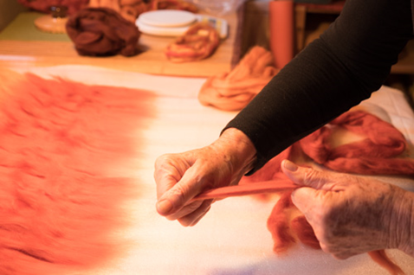Wool is massaged by hand or with a sponge using soap and warm water to start the process of interlocking the fibers. This challenging process is complicated by wool moving from its intimal placement once wetted. However, to Duff, the process of creating the wool into felt is one of the reasons why she loves this art form.

Edda Duff hands stretches wool and places it into layers.

“Massaging the wool with warm water and soap is so luxurious,” Duff said. “It is warm and soft and you feel the fibers under your hands changing.”

Felt creations can surprise the artist. When Duff creates colorful hats, they don’t always come out 100% the way she had envisioned; yet, they still look stunning.

(more)

“Wool is very forgiving,” Duff said. “If I make a mistake it doesn’t show, and sometimes the mistake can be an enhancement [to the pattern].”

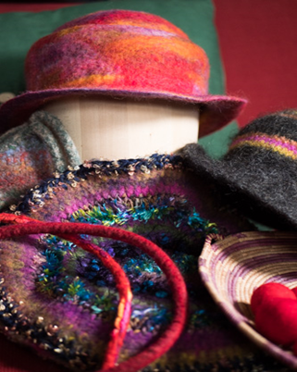

Edda Duff creates an assortment of felt accessories.

As Duff learned more about enhancing her art by creating hats, purses and other accessories, she decided to share her talent with the community.

OASIS, an art gallery in Harrisonburg, came to mind as a possible venue for her products. Duff had first encountered OASIS when she was a daycare teacher, looking for a place to have interesting field trips with the kids.

Members of OASIS welcomed the children with open arms. Duff liked how in OASIS’s floor plan includes a section for children upstairs. Members of the cooperative also taught art classes to children. After that initial encountering, Duff went back a few more times to OASIS to look and purchase artwork.

(more)

Duff made it her goal to get her artwork displayed in OASIS. By fall 2016, she was inducted as a new member of OASIS Fine Art & Craft.

“OASIS has very hardworking members and there’s a sense of trust when we are handling each’s other’s work,” Duff said.

Duff was anxious the first time she displayed a piece in the gallery, but the support of other OASIS members helped her misgivings.

Felting is a true gift Duff possesses, and being a part of OASIS gave her the confidence to showcase it to the community. Duff learns different elements to add to her art by attending workshops or meetings with other members. Then she creates new piece that are incorporated in the gallery.

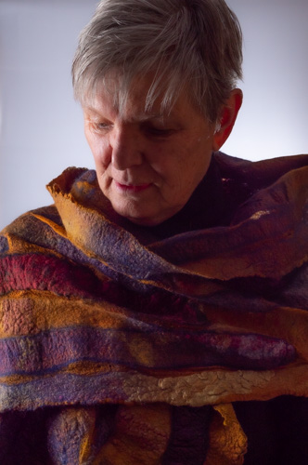A piece Duff created as a result of workshop is a shawl that she will never sell. To Duff, it’s a special feeling to create beauty from hard work, and the shawl combines both.

Duff spends her days working alongside OASIS fellow members or hosting Saturday art classes for children. Every second Saturday of the month, Duff goes back to her teaching roots and presents her lessons in the morning. The lessons have specific themes that teach kids key elements of art making.

Edda Duff, felting artist, modeling her shawl.

(more)

Duff’s retirement hobby turned out to be her passion, now on display for others to see. The love she puts into her artwork is part of every hat, bag or shawl that Duff beautifully crafts.

The art of felting has connected Duff to her Germanic past, but as a member of OASIS, she looks towards the future to teach Harrisonburg residents an appreciation for ancient textile techniques.

“I just love it,” Duff said.

-End-

**About OASIS Fine Art & Craft**

OASIS is a nonprofit co-op run by members. For almost 20 years, OASIS has exhibited 40 Shenandoah Valley area artists and artisans. Open seven days a week, OASIS is located in the heart of Harrisonburg, Virginia. For more information, call OASIS at 540-442-8188 or visit their website at [www.oasisfineartandcraft.com](http://www.oasisfineartandcraft.com). Stay up-to-date with their daily activities on Instagram and Facebook at oasisfineartandcraft.